**AZ Functions Assignment**

**Karan Kumar-Batch7**

**Http Trigger:**

To use Http trigger we have to make functionapp we will perform it in two ways through portal and VSCode.

**Through Portal :**

1:First create the resource group if not have already

2:Go to functionapp and click on create

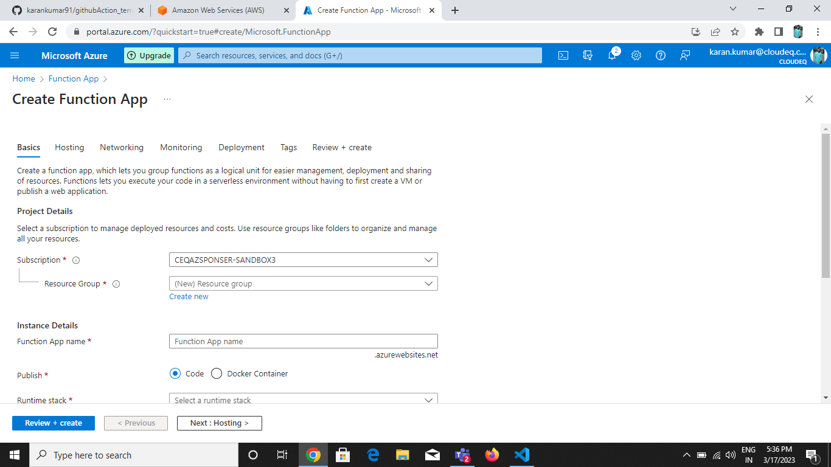

Enter the following detailsand always choose python version3.9,3.8 or 3.7

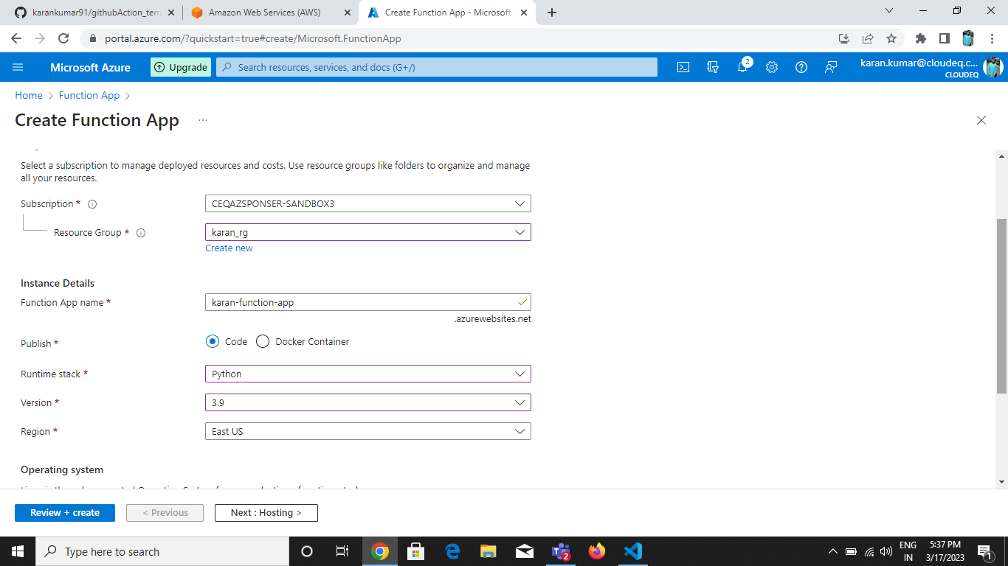

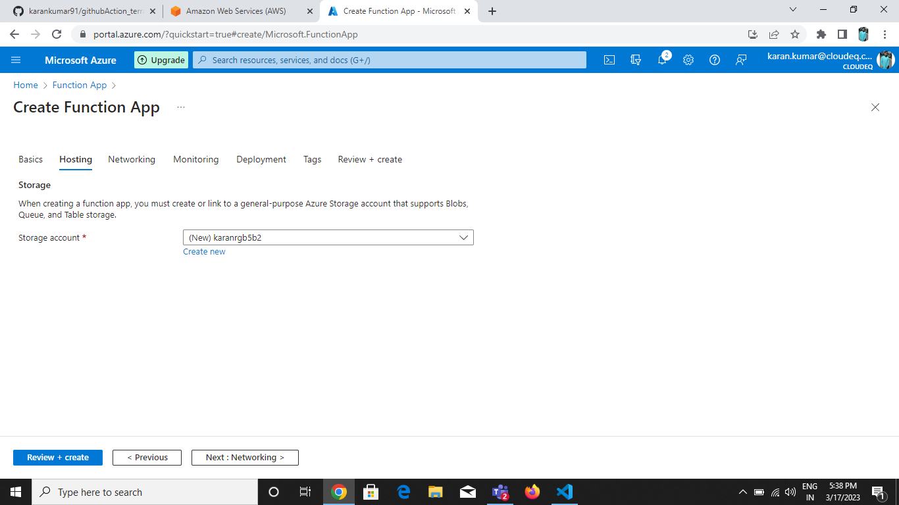



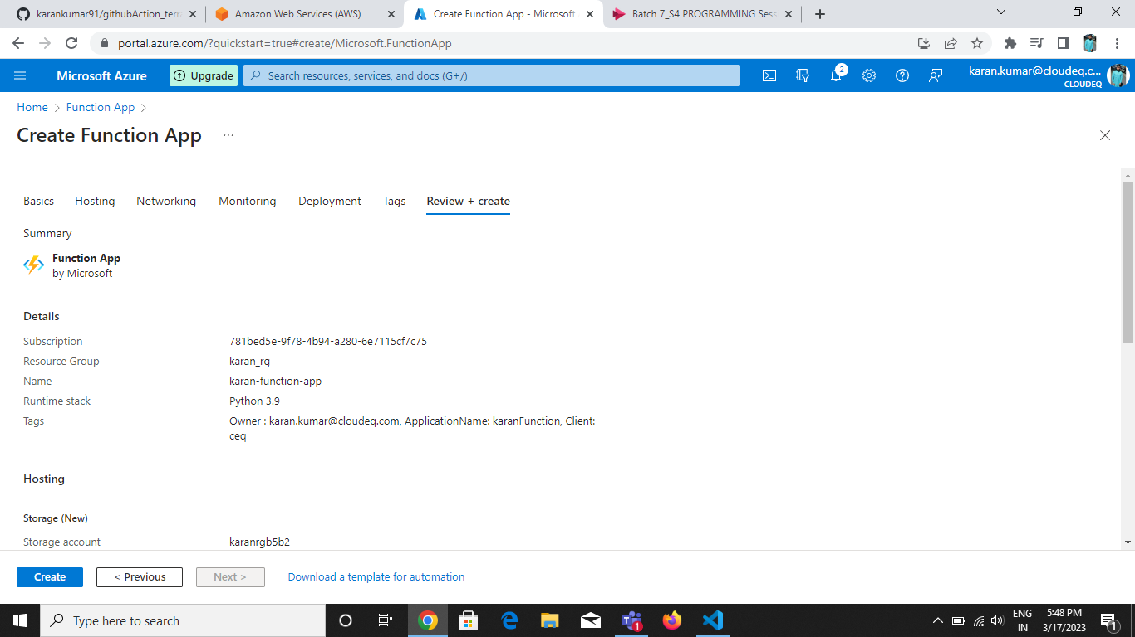

Clickon create after reviewing.

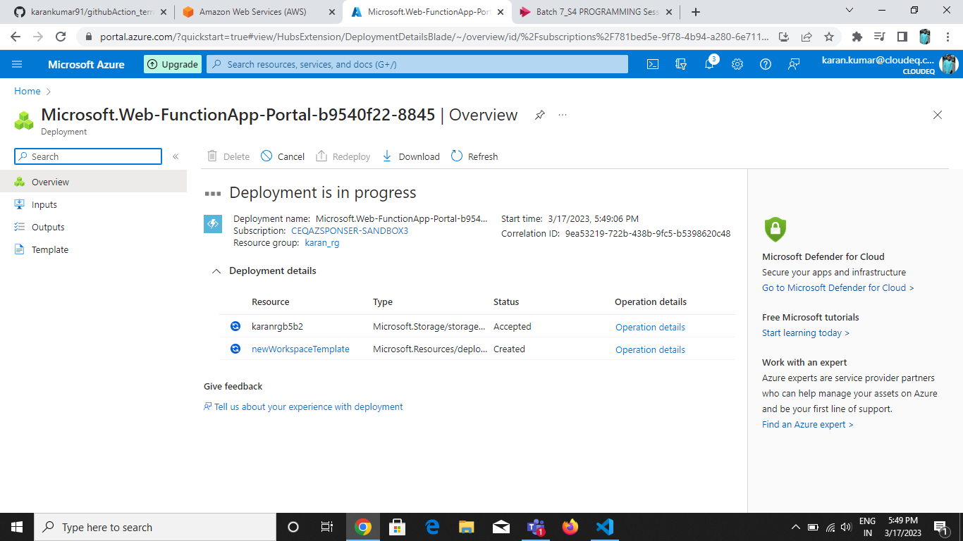

Deployement of function app is completed.

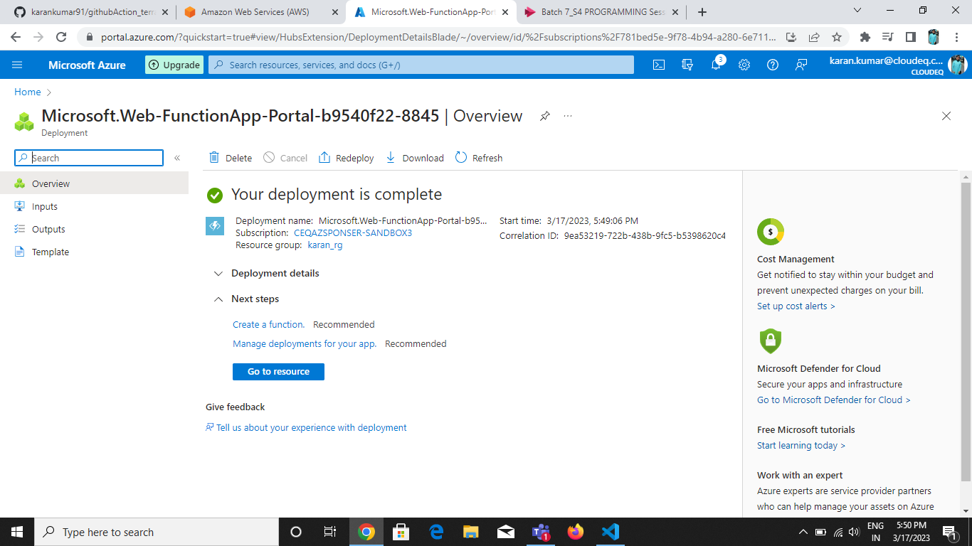

Now go to function in the function app and apply the http trigger.

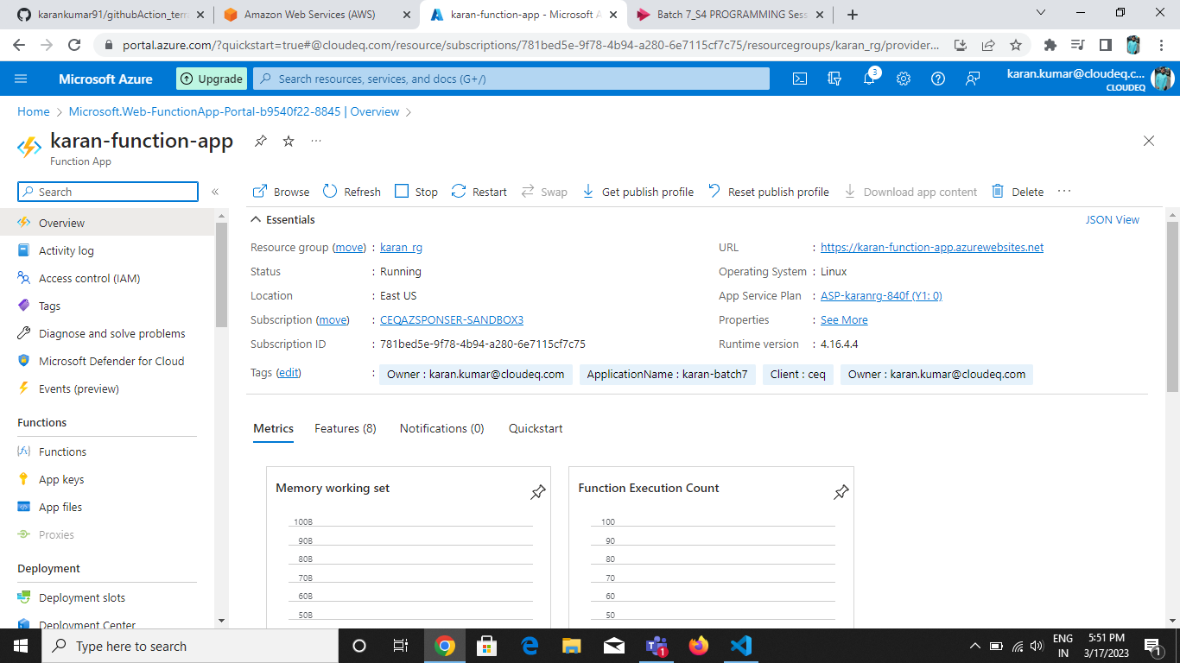

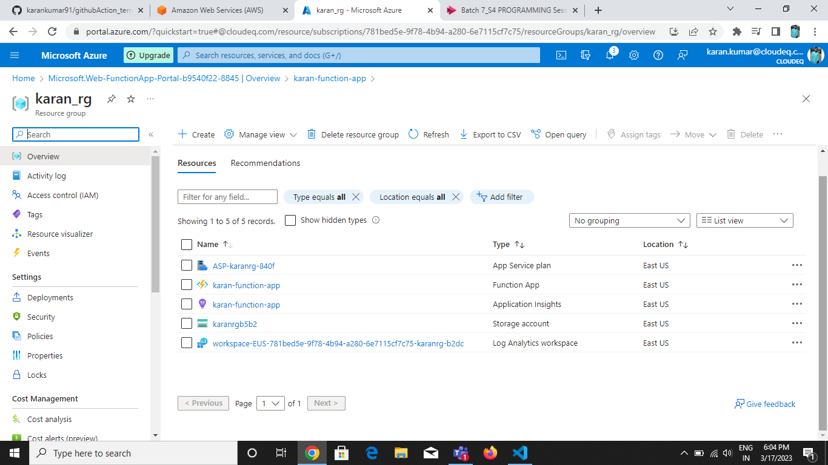

Click on function and create a function.

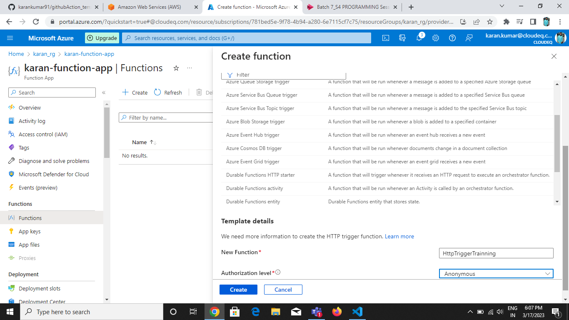

Select the Http Triggerand Authorization level Anonymous.



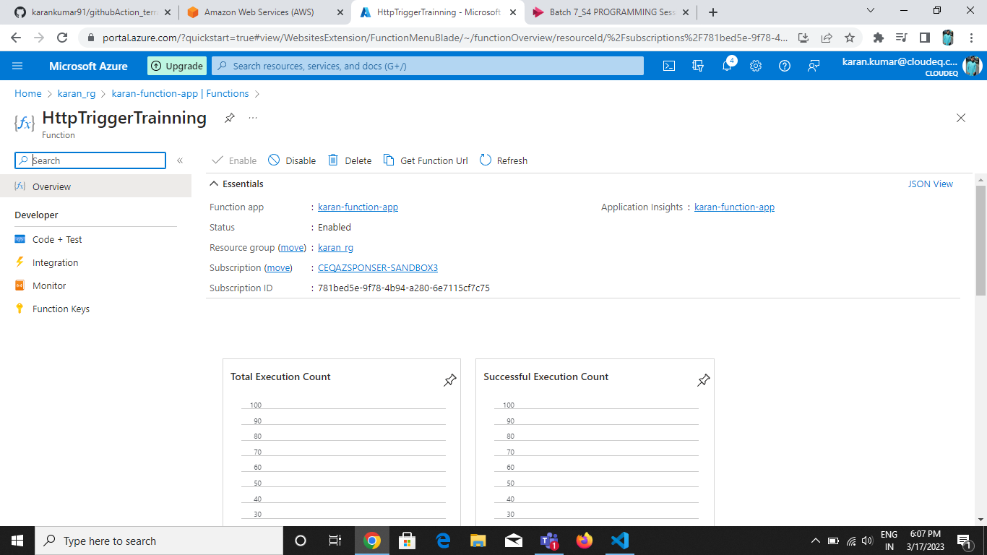

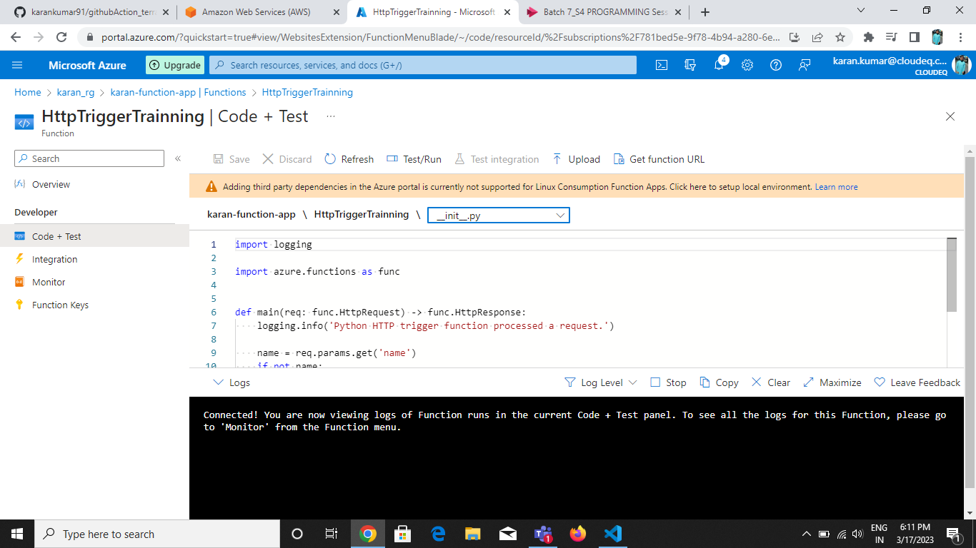

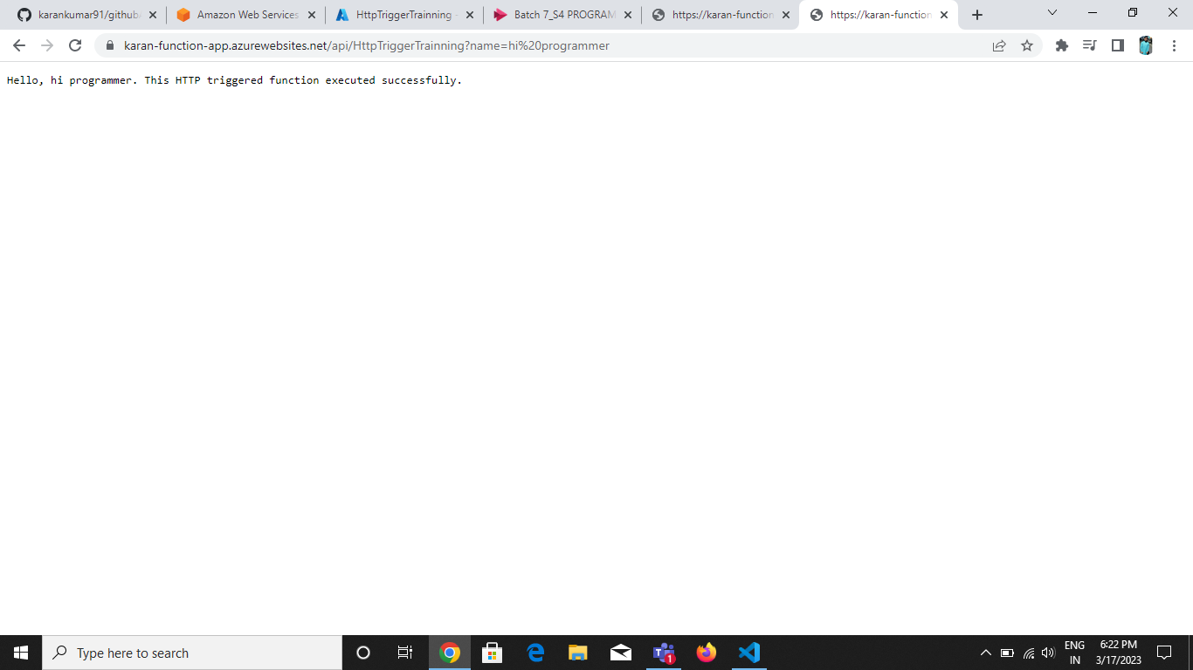

Go to Monitor and Check The log:

